Project Design Phase-II
Data Flow Diagram & User Stories

Date | 31 January 2025
Team ID
Project Name
Maximum Marks | 4 Marks

Data Flow Diagrams:
A Data Flow Diagram (DFD) is a traditional visual representation of the information flows within a system. A neat and clear DFD can depict the right amount of the system requirement graphically. It shows how data enters and leaves the system, what changes the information, and where data is stored.
Example: DFD Level 0 (Industry Standard)
Example: (Simplified)
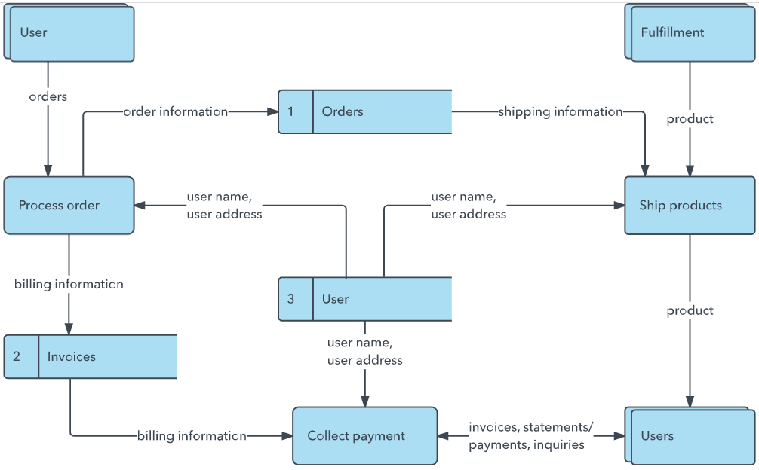


ShopEZ Data Flow:

1. User opens the browser and visits localhost:3000
2. React frontend sends a request to Express backend at localhost:5000
3. Express processes the request and queries MongoDB
4. MongoDB returns the data to Express
5. Express sends the response back to React
6. React displays the data to the user

User Stories
Use the below template to list all the user stories for the product.
User Type | Functional Requirement (Epic) | User Story Number | User Story / Task | Acceptance criteria | Priority | Release
Customer (Mobile user) | Product Catalog | USN-6 | As a user, I can browse all products on the home page | Products are displayed with name, price, image and stock | High | Sprint-2
Customer (Web user) | Product Catalog | USN-7 | As a user, I can filter products by category | Only products from selected category are shown | High | Sprint-2
Customer (Web user) | Product Catalog | USN-8 | As a user, I can search for products by name | Matching products appear in real time | Low | Sprint-2
Customer (Web user) | Cart | USN-9 | As a user, I can add a product to my cart | Product appears in cart with correct quantity | High | Sprint-3
Customer (Web user) | Orders | USN-10 | As a user, I can place an order from my cart | Order is saved and cart is cleared | High | Sprint-1
Administrator | Product Management | USN-11 | As an admin, I can add a new product | Product appears in the catalog immediately | High | Sprint-4
Administrator | Product Management | USN-12 | As an admin, I can edit or delete a product | Changes reflect immediately on the home page | High | Sprint-4
Administrator | Order Management | USN-13 | As an admin, I can view all orders placed by users | All orders shown with user details and items | Medium | Sprint-4

